# The efficient production of MOCVD-derived double-sided 2-in YBCO thin films

## R Chen1, B W Tao1, *, R P Zhao1, G Y He1, C Zeng2 and X Y Lu2

1 State Key Lab of Electronic Thin Films and Integrated Devices, University of Electronic Science and Technology of China, Chengdu, 610054, People’s Republic of China

2 School of Opto-Electronic Information, University of Electronic Science and Technology of China Chengdu 610054

E-mail:taobw@uestc.edu.cn

## Abstract

A double-sided deposition device was designed and applied in our home-made MOCVD system to efficiently produce double-sided YBCO thin films. With it, at most 12 pieces of double-sided 2-in YBCO thin films could be prepared simultaneously. In this paper, 500 nm thick YBCO thin films were simultaneously deposited on both sides of 2-in LaAlO3 single crystalline substrates at an average preparation rate of 23 min per piece. The YBCO thin films made in this way maintained good consistency both in-plane and double-sided. Meanwhile, the critical density is between 2.2-2.4 MA·cm-2 (77K,0T)，and the microwave surface resistance is 0.323 mΩ (77K,10GHz) that has meet the commercial demand of microwave devices.

Keywords: MOCVD YBCO double-sided efficient

## 1.Introduction

YBa2Cu3O7-delta (YBCO) high temperature superconductor (HTSC) thin films on LaAlO3 (LAO) single crystal have been widely used for microwave devices, because of its excellent property of high current capacity and low microwave losses[1-10]. The microwave filters with double-sided YBCO thin films have much lower insertion loss and stronger anti-interference capability compared to ordinary filters[11-14]. Earlier time， double-sided YBCO thin films prepared by depositing the second side after the first side has been finished[15-17], which had negative impacts on the double-sided consistency and made the deposition process complicated. Gradually, simultaneous deposition route to prepare double-sided YBCO thin films has been developed and made progress [18-20].

With great effort, double-sided YBCO thin films with good performance had been prepared successfully with different deposition methods all over the world[18-22], but the price is still too high due not only to the high cost of preparation, but also to the low preparation efficiency. Nowadays, the main preparation methods of YBCO thin films for microwave usage on single crystal include co-evaporation[16, 21], sputtering[18, 19], pulsed laser deposition (PLD)[9, 20] and metal organic deposition (MOD)[22-24]. Co-evaporation method can be used to deposit single-sided YBCO thin films in batch rapidly, but it is difficult to simultaneously deposit double-sided thin films due to the raw material melting. With the PLD method, the films are still deposited one side after the other and it takes more than 6 hours to make a sample. The traditional sputtering method, of which the depositing rate is only about several nanometers per minute, usually takes time longer than working hours to prepare a piece of 500 nm thick double-sided YBCO thin films. As for MOD method, just the decomposition process takes approximately 10 hours.

In recent years, metal organic chemical vapor deposition (MOCVD) method has been improved and make a quick progress in the preparation of YBCO high temperature superconducting (HTS) tapes as a low cost large-scale production method[25-28]. As is reported, the deposition rate of YBCO thin films on tapes has reached up to 1um min-1. so we transplanted it into the preparation of YBCO thin films on single crystal. As is reported, the deposition rate of YBCO thin films on tapes has reached up to 1μm·min-1[25]. This fast deposition method for HTS tapes should be also suitable for YBCO thin films on single crystals only if it could deposit on the both sides of the substrates.

Meanwhile, in order to further improve the efficiency of preparation, the pre-preparation that cost several hours such as heating and preparation of the precursor solution, and post-annealing should also be taken into account. The efficiency of the preparation of YBCO thin films would greatly enhanced if multi-pieces of YBCO thin films rather than only one were deposited in one run.

In the paper, a double-sided MOCVD deposition device was designed to prepare multi-pieces of double-sided YBCO thin films simultaneously and efficiently. The test results of the double-sided YBCO thin films on indicated that the critical current density (*Jc*) is between 2.2-2.4 MA·cm-2(77K) and the microwave surface resistance (*Rs*) is 0.323 mΩ (77K,10GHz), which has meet the commercial demand of microwave devices (*Jc*>=2.0 MA·cm-2(77k, 0T), *Rs*<0.5 mΩ (77K,10GHz)).

## 2.Experiment

A double-sided deposition device, which contained a planetary turntable rotating disk for holding substrates and a shower with two opposite symmetrical narrow slits, was designed to prepare multi-pieces of double-sided YBCO thin films simultaneously and efficiently as is shown in Figure 1. The planetary turntable disk having 12 circumferentially shaped openings, in which substrate wafers were maintained, was applied to deposit YBCO thin films on multiply pieces of LAO substrate wafers as is shown in Figure 1(a). With it, at most 12 pieces of YBCO thin films could be deposited in one run, significantly shortening the preparation progress of each YBCO thin films. And the shower head with two opposite symmetrical narrow slits was used to deposit YBCO thin films on both sides of a LAO wafer simultaneously as is shown in figure 1(b). In this way, the efficient production of MOCVD-derived double-sided YBCO thin films was realized.

In our experiment, 2-in LAO single crystal wafers were used as substrates for YBCO thin films. Before depositing thin films, the deposition chamber was heated to 845℃, while the evaporation chamber and transport pipeline were heated to 300℃. Meanwhile, Y(tmhd)3, Ba(thmd)2·(1,10-heptanedionate), Cu(thmd)2 were dissolved into tetrahydrofuran solution in a proper proportion, where ‘thmd’ is the abbreviation of 2,2,6,6, -tetramethy-3,5-heptanedioline. The pre-preparation for the deposition of YBCO thin films took about 140 minutes. Figure 1 shows the schematic diagram of the rotating double-sided deposition device for the efficient preparation of double-sided YBCO thin films. As is shown in figure 1(a), the planetary turntable has 12 circumferentially shaped openings which are used to hold the LAO wafers. The diameter of the openings was a little bigger than 2 inches (the diameter of LAO substrates). Upon rotation of the substrate turntable, the substrates self-rotated within each opening due to the force of friction between the substrates and the openings. This will significantly reduce the variation of thickness in the plane. In figure 1(b), a shower having two opposite symmetrical narrow slits was designed to deposit double-sided YBCO thin films simultaneously. The position relationship of the planetary turntable and the shower head is shown in figure 1(c). During depositing, the precursor solution was evaporated to from vapor in the evaporator. Then the vapor was mixed up with the nitrous oxide, oxygen, argon in a proper gas flow ratio, and was transferred into the depositing area from the two narrow slits. Along with the rotation of the planetary turntable, YBCO thin films was deposited on both side of every LAO wafer uniformly. In order to obtain 500 nm thick YBCO double-sided thin films, the deposition was set for 75 minutes. Next, the temperature of the deposition chamber was reduced to 500℃ by adjusting heating current manually. After annealing for 20 minutes in pure oxygen, the YBCO thin films were cooled to a temperature below 100℃ slowly. On average, the post processing took about 60 minutes.

The thickness of YBCO thin films was measured by a step profiler (Veeco Dektak 150). The Jc was measured through the Leizig Jc-scan system and the Rs was measured through a sapphire resonance[29]. The texture was characterized by an x-ray diffraction system (XRD, DanDong DX-2700) with θ-2θ scan for crystal phase and orientation and ω-scan for out-of-plane orientation The surface morphology was characterized by a scanning electronic (SEM, JEOL7500F)..

## Table 1 The average preparation time of pre piece of double-sided 500nm thick YBCO thin films in a single experiment

|  |  |  |  |  |
| --- | --- | --- | --- | --- |
| Pre-preparation time (min) | Deposition time for 500 nm thick thin films (min) | Post preparation time (min) | Total time in a single experiment (min) | Average preparation rate (min pre piece) |
| 140 | 75 | 60 | 275 | 23 |

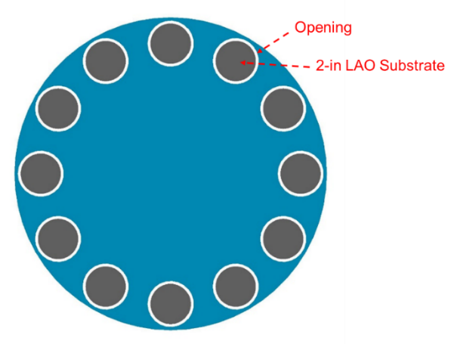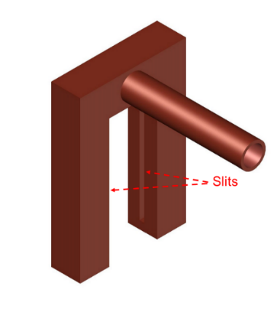

(a) (b)

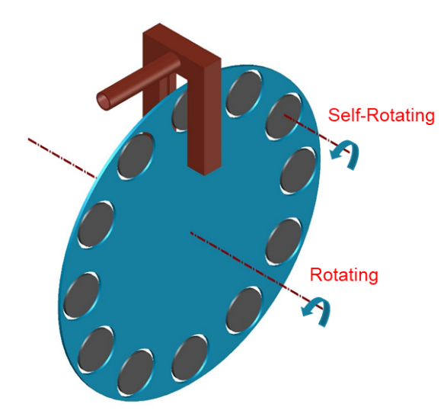

(c)

**Figure 1.** The double-sided deposition device:(a) the planetary turntable disk; (b) the shower head with two opposite symmetrical narrow slits; (c) the position relationship of the planetary and the shower head.

## 3.Results and discussion

### 3.1 The average preparation rate of double-sided YBCO thin films on LAO substrates

Due to the planetary turntable with 12 openings for substrates and the shower head with two opposite symmetrical narrow slits, up to 12 pieces of 2-in double-sided YBCO thin films can be prepared in a single experiment. Thus, the average preparation time of pre piece of double-sided YBCO thin films (*pre*) can be calculated by the formula:

*pr*e , (1)

where *T* is the total time of a single experiment. It could be divided into the pre-preparation time (*Tpre*), depositing time(*Tdep*) and post processing time (*Tpos*) as is described in chapter 2. The *Tpre* which includes the heating of reaction chamber, evaporation chamber and pipes as well as preparation of precursor solution is about 140 minutes. *Tdep* depends on the thickness of the required thin films, such as 75 min for 500 nm thick thin films. And *Tpos* is usually 60min.Then, the *T* can be obtained by the calculation of the formula:

*T* = *Tpre* + *Tdep* + *Tpos* , (2)

As is shown in table 1, the *pr*e which is calculated according to the measured results of experiments, is as large as around 23 min per piece.

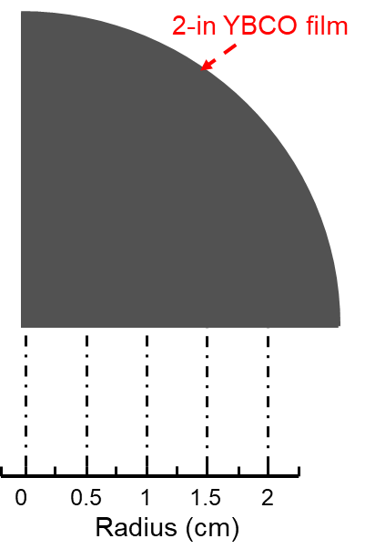

**Figure 2.** The testing radii of 2-in YBCO thin films

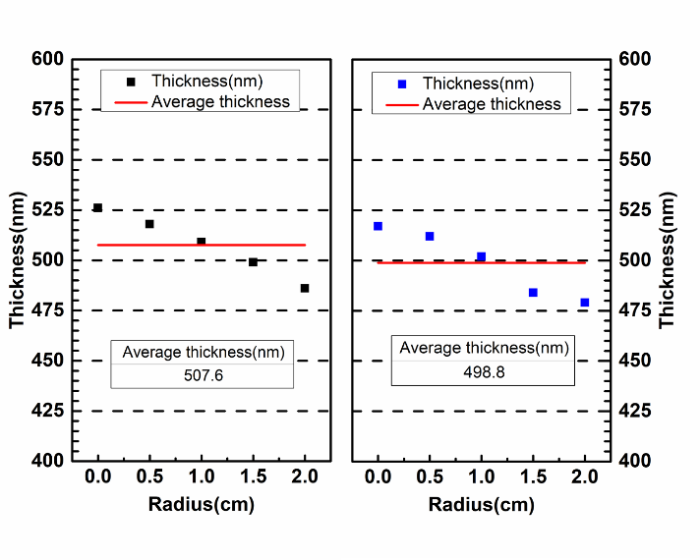

**Figure 3.** The variation of thickness of double-sided YBCO thin films at radii of 0, 0.5, 1, 1,5 ,2 cm



**Figure 4.** The XRD θ-2θ scanning patterns of double-sided YBCO thin films at radii of 0, 1, 2 cm of side A and B



**Figure 5.** The XRD ω scanning patterns of double-side YBCO thin films

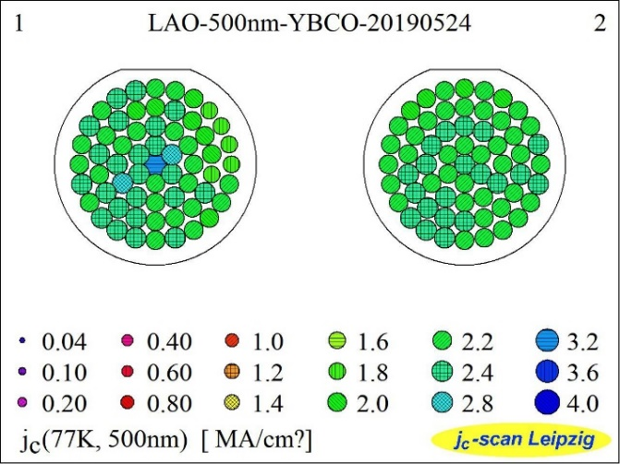

**Figure 6.** Homogeneity of Jc (77K,0T) of 2-in double-sided YBCO thin films



**Figure 7.** Transformation ofJc (77K, 0T) at radii of 0, 0.5, 1, 1.5 ,2 cm on both sides of a 2-in YBCO thin films

## 3.2 The measurement of the double-sided YBCO thin films

The thicknesses of both sides of the 2-in YBCO thin films were measured by a step profiler. As is shown in Figure 2, on each side, radii of 0, 0.5, 1, 1.5, 2 cm were selected for thickness measurement in order to test the consistency of double-sided YBCO thin films. According to the results in Figure 3, the average thickness of the two sides are approximately 507.6 nm and 498.8 nm, respectively. Meanwhile, the deviation of thickness of each side is lower than 10%, which indicates that the double-sided YBCO thin films is of good consistency.

The XRD θ-2θ scan maps of double-sided YBCO thin films, which were measured at radii of 0, 1, 2 cm are shown in Figure 4. Except the peaks of LAO at 23.4° and 47.9°, there are only YBCO *(00l)* peaks other than *(h00)* peaks in the θ-2θ curve, which indicates that almost all YBCO grains are c-axis-oriented as we expected.

The XRD ω-scan of the double-sided YBCO thin films, which were used to characterize the out-of-plane texture, were performed at the equivalent position of each side. As is shown in figure 5, the full width of half maximum (FWHM) of each side is 0.498° and 0.507° respectively that shows little difference between the two sides.

Figure 6 shows the measured results of Jc (77K, 0T) of 2-in double-sided YBCO thin films on LAO substrate. The *Jc* (77K, 0T) at every point measured is mainly between 2.2 MA cm-2 and 2.4 MA cm-2. As is shown in Figure 7, the variation of the Jc along the radius of each side of a 2-in double-sided YBCO thin films is small and the distinction between the two sides is not obvious.

In order to obtain Rs, a sapphire resonance was used to measure the quality factor(*Q*) of the YBCO films firstly [29]. As shown in Figure 8, the Q of 500nm YBCO films prepared is 87524 at the frequency of 31.506 GHz. The relationship between *Q* and *Rs* is as follow:

(1)

where A, B are only related to the electromagnetic fields distribution and can be determined by calibration. Therefore, the microwave surface resistant can be calculated by the formula:

. (4)

Meanwhile, the relationship of the Rs and the operating frequency(*f*)is as follow:

, (5)

where k is a constant. Thus, the microwave surface resistant (*Rs0*) at the frequency of 10GHz (*f0*) can be calculated by the formula:

(6)

and the calculation results are shown in table 2. The Rs0 is as low as 0.323mΩ which indicates that the YBCO thin films prepared has met the commercial demand of surface resistant of microwave devices.

As for the morphologies of the two sides of the double-sided YBCO thin films prepared on LAO substrates recently, As is shown in Figure 9, the surface morphologies were not as flat as expected. Still, we believe that the surface morphologies can be optimized as we have successfully obtained GdYBCO thin films with flat surface morphology on LaMnO3/MgO/Y2O3/Al2O3 buffer layer which is much harder than preparing YBCO thin films on LAO crystal substrates as is shown in Figure 10.

## 

**Figure 8.** The microwave surface resistance at the center of the 2-in 500nm thick YBCO films

## Table 2. The calculation results of the Rs of the 500nm thick YBCO films at 77K

|  |  |  |  |  |  |
| --- | --- | --- | --- | --- | --- |
| *Q* | *A* | *B*(mΩ-1) | *f0*(GHz) | *f* (GHz) | *Rs0*(mΩ) |
| 87524 | 8.294*10-6 | 9.767*10-4 | 10 | 31.056 | 0.323 |

## 4.Conclusion

In this paper, we presented a double-sided deposition device that used for the efficient production of MOCVD-derived double-sided 2-in YBCO thin films. Results indicated that the average preparation rate of 2-in double-sided 500 nm thick YBCO thin films was as fast as 23 minutes per piece. Meanwhile, the double-sided YBCO thin films maintained good consistency both in-plane and double-sided. And the critical current density of 500nm thick YBCO thin films with good biaxial texture is 2.2-2.4 MA cm-2(77K, 0T). Moreover, the microwave surface resistant was as low as 0.323mΩ(77K,10GHz) which met the commercial demand of microwave devices (Jc≥2.0 MA·cm-2(77k, 0T), Rs≤0.5 mΩ (77K,10GHz)). Thus, it illuminated that our design to prepare double-sided YBCO thin films efficiently was feasible



**Figure 9.** The SEM images of double sides of the YBCO thin films on LAO substrates

**Figure 10.** The SEM image of GdYBCO thin films on LaMnO3/MgO/Y2O3/Al2O3 buffer layer

## Acknowledgment

We gratefully acknowledge the support of the National Natural Science Foundation of China (No.51872040).

## Reference

[1] S.I. Bondarenko, V.P. Koverya, A.V. Krevsun, S.I. Link, High-temperature superconductors of the family (RE)Ba2Cu3O7-δ and their application (Review Article), in: Low Temperature Physics, 2017, pp. 1125-1151, doi:10.1063/1.5008405.

[2] L. Guo-Chun, Z. Dawei, S. Chien-Fu, M.E. Johansson, R.S. Withers, D.E. Oates, A.C. Anderson, P. Polakos, P. Mankiewich, E.d. Obaldia, R.E. Miller, High-power HTS microstrip filters for wireless communication, IEEE Transactions on Microwave Theory and Techniques, 43 (1995) 3020-3029, doi:10.1109/22.475668.

[3] A. Fathy, D. Kalokitis, V. Pendrick, E. Balohoubek, A. Pique, M. Mathur, Superconducting narrow band pass filters for advanced multiplexers, in: 1993 IEEE MTT-S International Microwave Symposium Digest, 1993, pp. 1277-1280 vol.1273, doi:10.1109/MWSYM.1993.277107.

[4] H. Jia-Sheng, M.J. Lancaster, D. Jedamzik, R.B. Greed, On the development of superconducting microstrip filters for mobile communications applications, IEEE Transactions on Microwave Theory and Techniques, 47 (1999) 1656-1663, doi:10.1109/22.788606.

[5] J.X. Jin, X. Ying, Q.L. Wang, Y.S. He, C.B. Cai, Y.S. Wang, Z.M. Wang, Enabling High-Temperature Superconducting Technologies Toward Practical Applications, IEEE Transactions on Applied Superconductivity, 24 (2014) 1-12, doi:10.1109/tasc.2014.2346496.

[6] J. Qiao, C.Y. Yang, High-Tc superconductors on buffered silicon: materials properties and device applications, Materials Science and Engineering: R: Reports, 14 (1995) 157-201, doi:10.1016/0927-796X(94)00172-3.

[7] D.E. Oates, G.F. Dionne, Magnetically tunable superconducting resonators and filters, IEEE Transactions on Applied Superconductivity, 9 (1999) 4170-4175, doi:10.1109/77.783944.

[8] S.H. Talisa, M.A. Janocko, C. Moskowitz, J. Talvacchio, J.F. Billing, R. Brown, D.C. Buck, C.K. Jones, B.R. McAvoy, G.R. Wagner, D.H. Watt, Low- and high-temperature superconducting microwave filters, IEEE Transactions on Microwave Theory and Techniques, 39 (1991) 1448-1454, doi:10.1109/22.83816.

[9] M. Lorenz, H. Hochmuth, D. Matusch, M. Kusunoki, V.L. Svetchnikov, V. Riede, I. Stanca, G. Kastner, D. Hesse, High-quality Y-Ba-Cu-O thin films by PLD-ready for market applications, IEEE Transactions on Applied Superconductivity, 11 (2001) 3209-3212, doi:10.1109/77.919747.

[10] Y. He, Y. Wang, Y. Hu, W. Chen, Z. Yan, Superconducting electrode capacitor based on double-sided YBCO thin film for wireless power transfer applications, Superconductor Science and Technology, 32 (2019), doi:10.1088/1361-6668/aaebd8.

[11] T. Zhang, Z. Long, L. Zhou, M. Qiao, F. Hou, M. Tian, Realization of Even Transmission Zeros for Filter Without Cross-Couplings, IEEE Transactions on Microwave Theory and Techniques, 66 (2018) 5248-5259, doi:10.1109/tmtt.2018.2871140.

[12] L.-M. Wang, W.-C. Lin, M.-L. Chang, C.-Y. Shiau, C.-T. Wu, Characteristics of Ultra-Wideband Bandpass YBCO Filter With Impendence Stub, IEEE Transactions on Applied Superconductivity, 21 (2011) 551-554, doi:10.1109/tasc.2010.2091231.

[13] S. Kolesov, H. Chaloupka, A. Baumfalk, T. Kaiser, Planar HTS structures for high-power applications in communication systems, Journal of Superconductivity, 10 (1997) 179-187, doi:10.1007/bf02770548.

[14] L. Gao, L. Sun, F. Li, Q. Zhang, Y. Wang, T. Yu, J. Guo, Y. Bian, C. Li, X. Zhang, H. Li, J. Meng, Y. He, 8-GHz Narrowband High-Temperature Superconducting Filter With High Selectivity and Flat Group Delay, IEEE Transactions on Microwave Theory and Techniques, 57 (2009) 1767-1773, doi:10.1109/TMTT.2009.2022813.

[15] G. Muller, B. Aschermann, H. Chaloupka, W. Diete, M. Getta, B. Gurzinski, M. Hein, M. Jeck, T. Kaiser, S. Kolesov, H. Piel, H. Schlick, R. Theisejans, Double-sided YBa/sub 2/Cu/sub 3/O/sub 7-/spl part// films for planar high-power filters, IEEE Transactions on Applied Superconductivity, 7 (1997) 1287-1290, doi:10.1109/77.620754.

[16] H. Kinder, P. Berberich, B. Utz, W. Prusseit, Double sided YBCO films on 4" substrates by thermal reactive evaporation, IEEE Transactions on Applied Superconductivity, 5 (1995) 1575-1580, doi:10.1109/77.402874.

[17] Y. Ito, Y. Yoshida, M. Iwata, Y. Takai, I. Hirabayashi, Preparation of double-sided YBa2Cu3O7−δ film by hot-wall type MOCVD, Physica C: Superconductivity, 288 (1997) 178-184, doi:10.1016/S0921-4534(97)01573-6.

[18] X.Z. Liu, B.W. Tao, X.W. Deng, Y. Zhang, Y.R. Li, The preparation of two inch double-sided YBCO thin films, Superconductor Science and Technology, 15 (2002) 1698-1700, doi:10.1088/0953-2048/15/12/313.

[19] F. Ding, H. Gu, T. Li, J. Cao, X. Lv, Y. Lei, Batch production of large-area double-sided YBa2Cu3O7−δ thin films by DC magnetron sputtering, Superconductor Science and Technology, 22 (2009), doi:10.1088/0953-2048/22/5/055019.

[20] M. Lorenz, H. Hochmuth, D. Natusch, K. Kreher, Highly reproducible large-area and double-sided pulsed laser deposition of HTSC YBCO:Ag thin films for microwave applications, Applied Physics A, 69 (1999) S905-S911, doi:10.1007/s003390051556.

[21] W. Prusseit, R. Semerad, K. Irgmaier, G. Sigl, Optimized double sided DyBa2Cu3O7-thin films for RF applications, Physica C: Superconductivity, 392-396 (2003) 1225-1228, doi:10.1016/S0921-4534(03)01028-1.

[22] T. Manabe, M. Sohma, I. Yamaguchi, K. Tsukada, W. Kondo, K. Kamiya, T. Tsuchiya, S. Mizuta, T. Kumagai, Surface resistances of 5-cm-diameter YBCO films prepared by MOD for microwave applications, Physica C: Superconductivity and its Applications, 445-448 (2006) 823-827, doi:10.1016/j.physc.2006.04.042.

[23] S.S. Wang, Z.L. Zhang, L. Wang, L.K. Gao, J. Liu, High quality uniform YBCO film growth by the metalorganic deposition using trifluoroacetates, Physica C: Superconductivity and its Applications, 534 (2017) 68-72, doi:10.1016/j.physc.2017.02.001.

[24] M. Sohma, K. Tsukada, I. Yamaguchi, K. Kamiya, W. Kondo, T. Kumagai, T. Manabe, Cerium Oxide Buffer Layers on Perovskite-Type Substrates for Preparation of C -Axis-Oriented YBa2Cu3O7−δ Films by Fluorine-Free Metalorganic Deposition, IEEE Transactions on Applied Superconductivity, 19 (2009) 3463-3466, doi:10.1109/TASC.2009.2018822.

[25] R. Zhao, Q. Liu, F. Zhang, Y. Xia, H. Tang, Y. Lu, C. Cai, B. Tao, Y. Li, High Rate Growth of MOCVD-Derived GdYBCO Films Based on a Simple Self-Heating Method, Journal of Electronic Materials, 47 (2018) 7062-7068, doi:10.1007/s11664-018-6632-8.

[26] R. Zhao, F. Zhang, Q. Liu, Y. Xia, Y. Lu, C. Cai, J. Xiong, B. Tao, Y. Li, MOCVD-derived multilayer Gd0.5Y0.5Ba2Cu3O7−δfilms based on a novel heating method, Superconductor Science and Technology, 30 (2016) 025023, doi:10.1088/1361-6668/30/2/025023.

[27] F. Zhang, R. Zhao, Y. Xue, H. Wang, Y. He, P. Zhang, B. Tao, J. Xiong, Y. Li, Self-heating technique of metallic substrate for reel-to-reel and double-sided deposition of YBa2Cu3O7−δfilms, Applied Physics A, 122 (2016) 81, doi:10.1007/s00339-015-9575-4.

[28] S. Miyata, K. Matsuse, A. Ibi, T. Izumi, Y. Shiohara, T. Goto, High-rate deposition of YBa2Cu3O7−δhigh-temperature superconducting films by IR-laser-assisted chemical vapor deposition, Superconductor Science and Technology, 26 (2013) 045020, doi:10.1088/0953-2048/26/4/045020.

[29] C. Zeng, Z. Luo, S. Bu, K. Yang, Q. Zhang, A novel method for the measurement of frequency-character of surface resistance of HTS thin film, Chinese Science Bulletin, 55 (2010) 1088-1091, doi:10.1007/s11434-009-0639-8.